**Capacitor Network Worksheet**

## Introduction

In this worksheet/lab, we will examine the properties of capacitor networks in series and parallel configurations. We will use the formulae for determining the equivalent capacitance of these networks to calculate the capacitance of capacitors connected in parallel and those connected in series.

The second part of this exercise will ask us to build parallel and series capacitor networks and examine circuit properties for these networks. We will also use the charge time profile to measure the actual equivalent capacitances to compare to the calculated values.

## Discussion Overview

### Parallel and Series Capacitor Networks

#### Parallel Networks

When components are connected in parallel, the voltage across each component in the parallel configuration is the same. This was true for resistors and is true for capacitors as well. In the case of capacitors, it means that, as the capacitors are charging, the voltages across the capacitors are the same. Therefore, the final fully charged voltage of all the capacitors in parallel are the same and equal to the source voltage:

Eq.

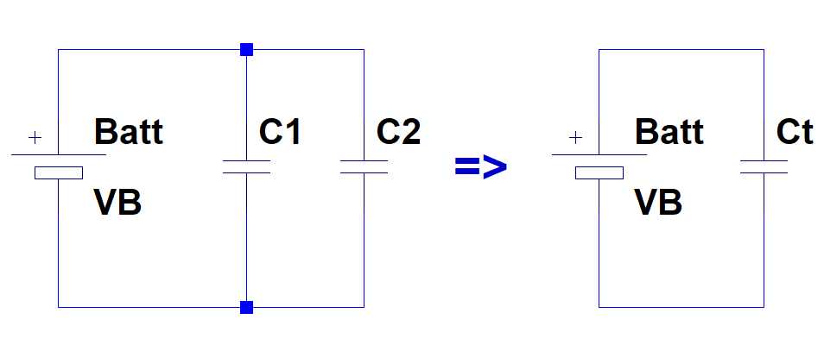

Each capacitor is collecting charge; so, the total charge across the capacitors is equal to the sum of the charges on each capacitor.

Eq.

From charge and capacitance formula, however, we know that

Eq.

Therefore,

Eq.

However, since , and ,

Eq.

And, therefore,

Eq.

#### Series Networks

In series networks, we know from Kirchhoff’s Voltage law that the sum of the voltages across individual components is equal to the total voltage across the full network. Therefore, for two capacitors in a series configuration, we have

Eq.

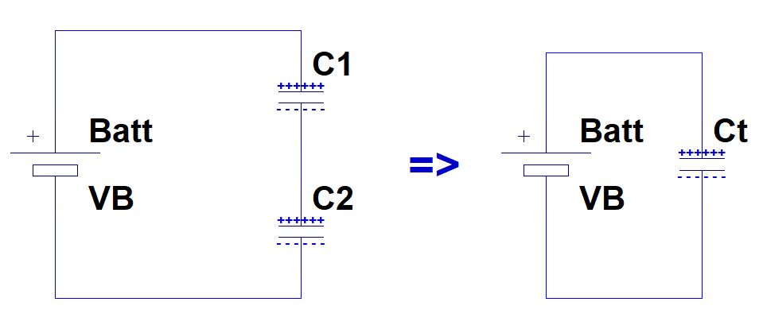

The charge accumulation on each capacitor is, however, the same. This can be seen from the fact that if the negative charge on the bottom plate of C1 in the diagram above is more than the positive charge on the top plate of C2, the charges would move through the wire connecting them until there is equal amount of negative and positive charge on bottom plate of C1 and top plate of C2 respectively. Therefore,

Eq.

Rearranging the charge and capacitance formula in Eq. 3, we have

Eq.

Plugging Eq. 9 into the KVL for series circuits Eq. 7, we have

Eq.

From the equivalent circuit, however, we also have

Eq.

Combining Eq. 10 and Eq. 11, we have

Eq.

From Eq. 8, however, we know that all the charges are equal. Therefore,

Eq.

## Procedure

### Calculations

Consider the two circuits below and answer the following questions.

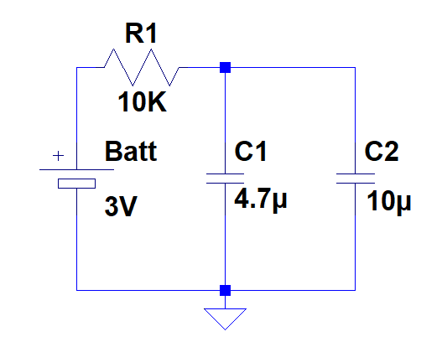

Figure – Parallel Capacitor Network

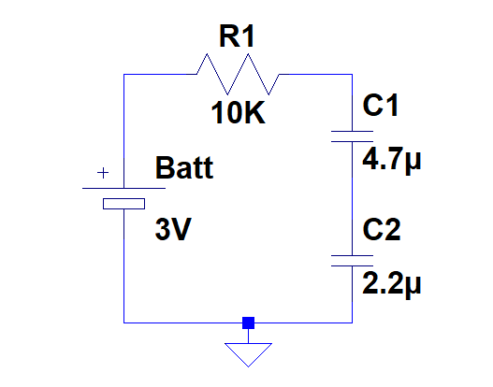

Figure - Series Capacitor Network

1. For the parallel network in Figure 1, do you believe the equivalent capacitance will be
$C_{t}>10μF$

$C_{t}<4.7μF$

$4.7μF<C_{t}<10μF$

2. Calculate the equivalent capacitance for the circuit in Figure 1: $$C_{t}=_______________________μF$$
3. When fully charged, determine the voltages across C1 and C2: $$V_{1}=_______________________V \\ V_{2}=_______________________V$$
4. For the series network in Figure 2, do you believe the equivalent capacitance will be
$C_{t}>4.7μF$

$C_{t}<2.2μF$

$2.2μF<C_{t}<4.7μF$

5. Calculate the equivalent capacitance for the circuit in Figure 2: $$C_{t}=_______________________μF$$
6. When fully charged, determine the voltages across C1 and C2: $$V_{1}=_______________________V \\ V_{2}=_______________________V$$

### Measurements

1. Build the circuit in Figure 1 on a breadboard.
   1. Place a 10K resistor in series with the capacitor network build in step 1.
   2. Connect the circuit to the waveform generator.
   3. Set the output of the waveform generator to a square wave with
      1. A peak to peak voltage of 3V.
      2. An offset of 1.5V. (Note that the waveform should go from a minimum of 0V to a maximum of 3V.)
   4. Connect the oscilloscope’s probe to across the capacitor network in your circuit.
   5. Adjust the horizontal setting and waveform’s frequency to clearly capture the charge (rise) time for the capacitor network.
   6. What is the final fully charged voltage across the capacitors? $$V_{f}=_______________________V$$
   7. What is the 95% value of this fully charged voltage? $$V_{95\%}=0.95V_{f}=_______________________V$$
   8. How long does it take the capacitors to charge from 0V to the 95% value above?
   9. The 95% charge time is equal to 3 times the RC value. What is, therefore, the equivalent capacitance of your circuit? $$t_{95\%}=3RC⇒C=\frac{t_{95\%}}{3R}⇒C=______________________μF$$
   10. How does this value compare to your calculated value in step 2 of the previous section?
2. Repeat the steps 1a-1e above for the circuit in Figure 2.
   1. What is the final fully charged voltage across the capacitors? $$V_{f}=_______________________V$$
   2. What is the 95% value of this fully charged voltage? $$V_{95\%}=0.95V_{f}=_______________________V$$
   3. How long does it take the capacitors to charge from 0V to the 95% value above?
   4. The 95% charge time is equal to 3 times the RC value. What is, therefore, the equivalent capacitance of your circuit? $$t_{95\%}=3RC⇒C=\frac{t_{95\%}}{3R}⇒C=______________________μF$$
   5. How does this value compare to your calculated value in step 5 of the previous section?